Catholic Social  Year: 2023/24 Year Group: 4 Teaching Staff: Luke Crickwood  SANCTUS SANCTUS SANCTUS  We all strive to live holy lives at All Saints through “… love that is patient and kind” that “never gives up” enabling us to “Go out into the world, and love the people we meet.” (Saint Paul and Saint Teresa)"  Teaching Principle | Areas covered within our CUSP curriculum  Autumn Spring Summer
Promoting peace  KEY STATEMENT: We can be God’s instruments of peace through seeking justice.  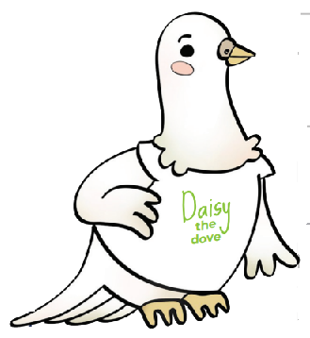 | “...those who promote peace have joy.” Proverbs 12:20  “The measure of the greatness of a society is found in the way it treats those most in need, those who have nothing apart from their poverty!” Pope Francis, 26 July 2013  Boy at the back of the class by Onjali Q Rauf – Promoting peace and support for refugees of war.
Distributive Justice  KEY STATEMENT: Everyone should have access to their fair share of resources.   | “All who believed were together and had all things in common.” Acts 2:44-45  “...we are agreed today that the earth is essentially a shared inheritance, whose fruits are meant to benefit everyone”’ Pope Francis, Laudato Si’, 93  Britain’s settlement by the Anglo-Saxons – peaceful migration and sharing of resources with the Romano-British.  Digestion – Looking at the effects of poor diet and why we should ensure that everyone gets enough to eat.  The girl who stole and elephant by Nizrana Farook – Ensuring all have access to resources not just the rich  River Nile and Amazon – Does everyone have fair access to the resources the rivers provide?
Preferential Option for the Poor  KEY STATEMENT The needs of poor and vulnerable people should be put first.  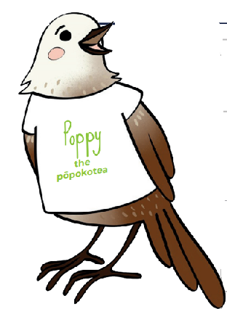 | “Learn to do good; seek justice, rescue the oppressed, defend the orphan, plead for the widow.” Isaiah 1:17  “The measure of the greatness of a society is found in the way it treats those most in need, those who have nothing apart from their poverty!” Pope Francis, 26 July 2013
Solidarity  KEY STATEMENT God created us as one global family called to support our brothers and sisters.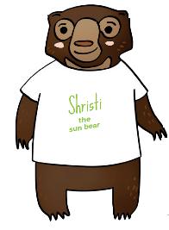 | “... all of you are one in Christ Jesus.” Galatians 3:28  “I prefer a Church which is bruised, hurting and dirty because it has been out on the streets, rather than a Church which is unhealthy from being confined and from clinging to its own security...while at our door people are starving and Jesus does not tire of saying to us: ‘Give them something to eat’ (Mark 6:37).” Pope Francis, Evangelii Gaudium, 49  Connected networks – We are all one part of a connected network; one global family  Boy at the back of the class by Onjali Q Rauf – Support for refugees of war – Fratelli Tutti  Varjak Paw – Looking after others in need and providing shelter to others who have none.
Stewardship  KEY STATEMENT We are guardians of God’s creation, living sustainably and enhancing the wellbeing of our planet.  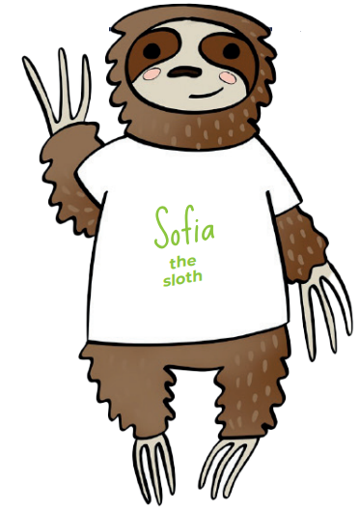 | “The Lord God took the man and put him in the garden of Eden to till it and keep it.” Genesis 2:15  “Humanity still has the ability to work together in building our common home” Pope Francis, Laudato Si’ 13  Rivers – Our local river (The river Nene) and how we can help to looking after it.  The girl who stole and elephant by Nizrana Farook – damage done to jungle environments due to human actions and conflicts.  Water Cycle – Pollution and keeping our waters clean.  River Nile and Amazon – How do we help to ensure that the rivers are not damaged by pollution?
Subsidiarity  KEY STATEMENT We are called to empower communities, to let everyone have a say.  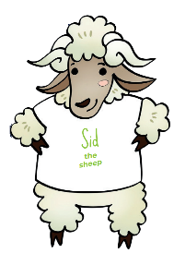 | Jethro said to Moses, “Let them bring every important case to you, but decide every minor case themselves.” Exodus 18:22  “Development programmes, if they are to be adapted to individual situations, need to be flexible; and the people who benefit from them ought to be directly involved in their planning and implementation.” Pope Benedict XVI, Caritas in Veritate, 47  Young, Gifted and Black by Jamia Wilson – celebrates to achievements of the black community.  The girl who stole an elephant by Nizrana Farook – enabling Sri Lankan (historically Serendib) communities to have a say in who is the ruler of the country.
Participation  KEY STATEMENT We all have the right and duty to participate fully in society.   | “When each separate part works as it should, the whole body grows and builds itself up through love.” Ephesians 4:16  “Each of us has a part to play, a gift to share, a service to offer, for building up the Body of Christ in love.” Pope Francis, 19 June 2013  Boy at the back of the class by Onjali Q Rauf – Doing our part to help others in need.  Varjak Paw – Need to do what is right even if it isn’t easy or simple
The Common Good  KEY STATEMENT We are called to work for the good of each and of all.  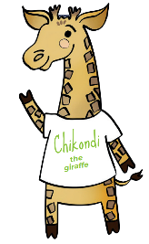 | “All who believed were together and had all things in common; they would... distribute the proceeds to all, as any had need.” Acts 2:44-45  “All who believed were together and had all things in common; they would... distribute the proceeds to all, as any had need.” Acts 2:44-45  “Beside the good of the individual, there is a good that is linked to living in society: the common good. It is the good of ‘all of us’...To desire the common good and strive towards it is a requirement of justice and charity.” Pope Benedict XVI, Caritas in Veritate, 7  The Queen’s nose by Dick King-Smith – Making a choice for the needs of others over our own wants.  The girl who stole an elephant by Nizrana Farook – campaigning for the good of all no matter how difficult it is.
Human Dignity  KEY STATEMENT We are beautifully made in the image and likeness of God.  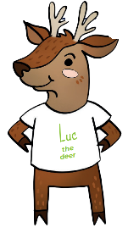 | God said, “Let us make humankind in our image, according to our likeness.“ Genesis 1:26  “Every person is worthy of our giving...they are God’s handiwork, his creation. God created that person in his image, and he or she reflects something of God’s glory. Every human being is the object of God’s infinite tenderness, and he himself is present in their lives.” Pope Francis, Evangelii Gaudium, 274  Young, Gifted and Black by Jamia Wilson – Celebrating members of the black community.  Boy at the back of the class by Onjali Q Rauf - We should treat others equally no matter where they come from or what they look like.  Varjak Paw – It is okay to be yourself.

