Catholic Social  Year: 2023/24 Year Group: 2 Teaching Staff: Amber Dickinson  SANCTUS SANCTUS SANCTUS  We all strive to live holy lives at All Saints through “… love that is patient and kind” that “never gives up” enabling us to “Go out into the world, and love the people we meet.” (Saint Paul and Saint Teresa)"  Teaching Principle | Areas covered within our CUSP curriculum  Autumn Spring Summer
Promoting peace  KEY STATEMENT: We can be God’s instruments of peace through seeking justice.  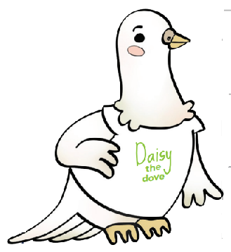 | “...those who promote peace have joy.” Proverbs 12:20  “The measure of the greatness of a society is found in the way it treats those most in need, those who have nothing apart from their poverty!” Pope Francis, 26 July 2013  Reading – Coming to England
Distributive Justice  KEY STATEMENT: Everyone should have access to their fair share of resources.   | “All who believed were together and had all things in common.” Acts 2:44-45  “...we are agreed today that the earth is essentially a shared inheritance, whose fruits are meant to benefit everyone”’ Pope Francis, Laudato Si’, 93
Preferential Option for the Poor  KEY STATEMENT The needs of poor and vulnerable people should be put first.  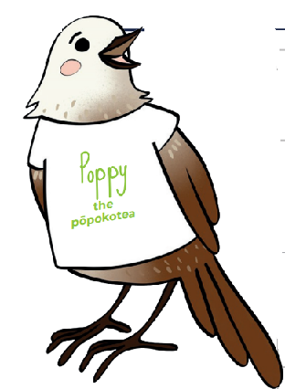 | “Learn to do good; seek justice, rescue the oppressed, defend the orphan, plead for the widow.” Isaiah 1:17  “The measure of the greatness of a society is found in the way it treats those most in need, those who have nothing apart from their poverty!” Pope Francis, 26 July 2013
Solidarity  KEY STATEMENT God created us as one global family called to support our brothers and sisters. | “... all of you are one in Christ Jesus.” Galatians 3:28  “I prefer a Church which is bruised, hurting and dirty because it has been out on the streets, rather than a Church which is unhealthy from being confined and from clinging to its own security...while at our door people are starving and Jesus does not tire of saying to us: ‘Give them something to eat’ (Mark 6:37).” Pope Francis, Evangelii Gaudium, 49
Stewardship  KEY STATEMENT We are guardians of God’s creation, living sustainably and enhancing the wellbeing of our planet.   | “The Lord God took the man and put him in the garden of Eden to till it and keep it.” Genesis 2:15  “Humanity still has the ability to work together in building our common home” Pope Francis, Laudato Si’ 13  Reading – Mrs Noah’s Pockets  Science – Living Things and Their Habitats  POP Day  Geography – Fieldwork
Subsidiarity  KEY STATEMENT We are called to empower communities, to let everyone have a say.  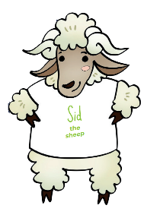 | Jethro said to Moses, “Let them bring every important case to you, but decide every minor case themselves.” Exodus 18:22  “Development programmes, if they are to be adapted to individual situations, need to be flexible; and the people who benefit from them ought to be directly involved in their planning and implementation.” Pope Benedict XVI, Caritas in Veritate, 47  Geography – Yanomami Tribe (CAFOD Links)
Participation  KEY STATEMENT We all have the right and duty to participate fully in society.   | “When each separate part works as it should, the whole body grows and builds itself up through love.” Ephesians 4:16  “Each of us has a part to play, a gift to share, a service to offer, for building up the Body of Christ in love.” Pope Francis, 19 June 2013  Reading - Paddington
The Common Good  KEY STATEMENT We are called to work for the good of each and of all.   | “All who believed were together and had all things in common; they would... distribute the proceeds to all, as any had need.” Acts 2:44-45  “All who believed were together and had all things in common; they would... distribute the proceeds to all, as any had need.” Acts 2:44-45  “Beside the good of the individual, there is a good that is linked to living in society: the common good. It is the good of ‘all of us’...To desire the common good and strive towards it is a requirement of justice and charity.” Pope Benedict XVI, Caritas in Veritate, 7  Reading – Rhythm of the Rain
Human Dignity  KEY STATEMENT We are beautifully made in the image and likeness of God.  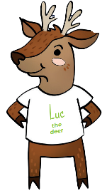 | God said, “Let us make humankind in our image, according to our likeness.“ Genesis 1:26  “Every person is worthy of our giving...they are God’s handiwork, his creation. God created that person in his image, and he or she reflects something of God’s glory. Every human being is the object of God’s infinite tenderness, and he himself is present in their lives.” Pope Francis, Evangelii Gaudium, 274  DT – Food and Nutrition  Science – Animals, including Humans  Reading – Fantastically Great Women who Changed the World  Healthy Bodies, Healthy Minds  Sports Day  Sporting Circles

